**Detailed steps on running the Spring Boot application**

Before importing the application on eclipse you need the following:

1. Mongo dB running on either locally or using the atlas mongo dB since this application will be using this NoSQL database.
2. Make sure your eclipse can run gradle since this application will was built on gradle.

Steps to run the spring boot application on eclipse

1. Open eclipse IDE and click on the file on the top left corner and head to the import and click to import the folder as shown on the image below.

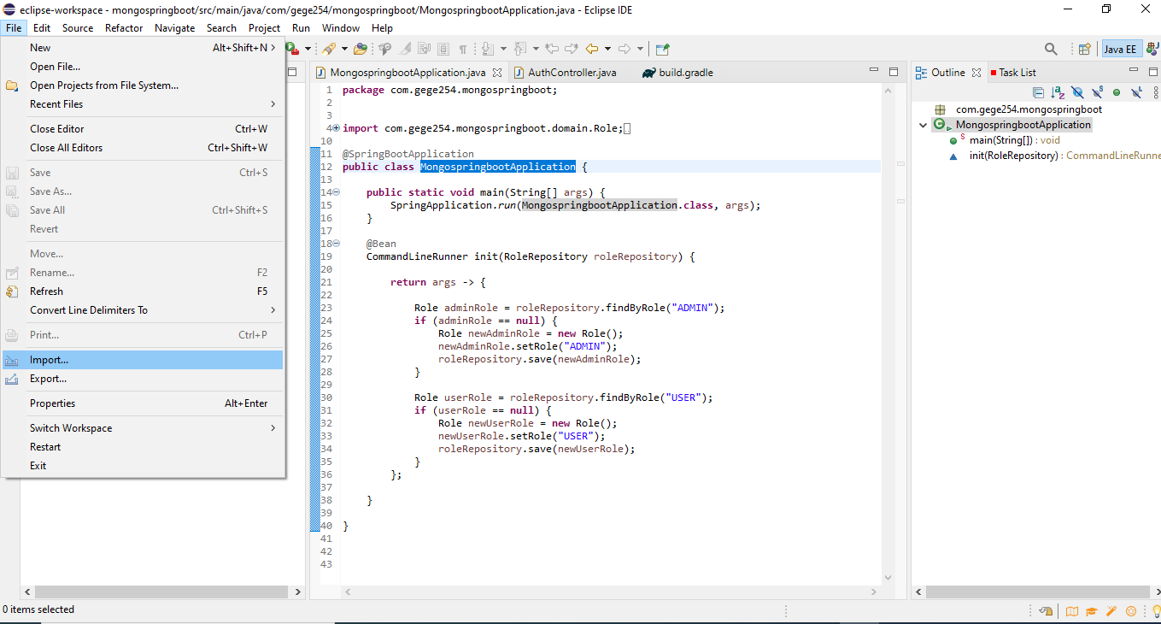

1. Once you have clicked the import button choose the gradle folder and when you expand it choose the existing gradle project and click next.

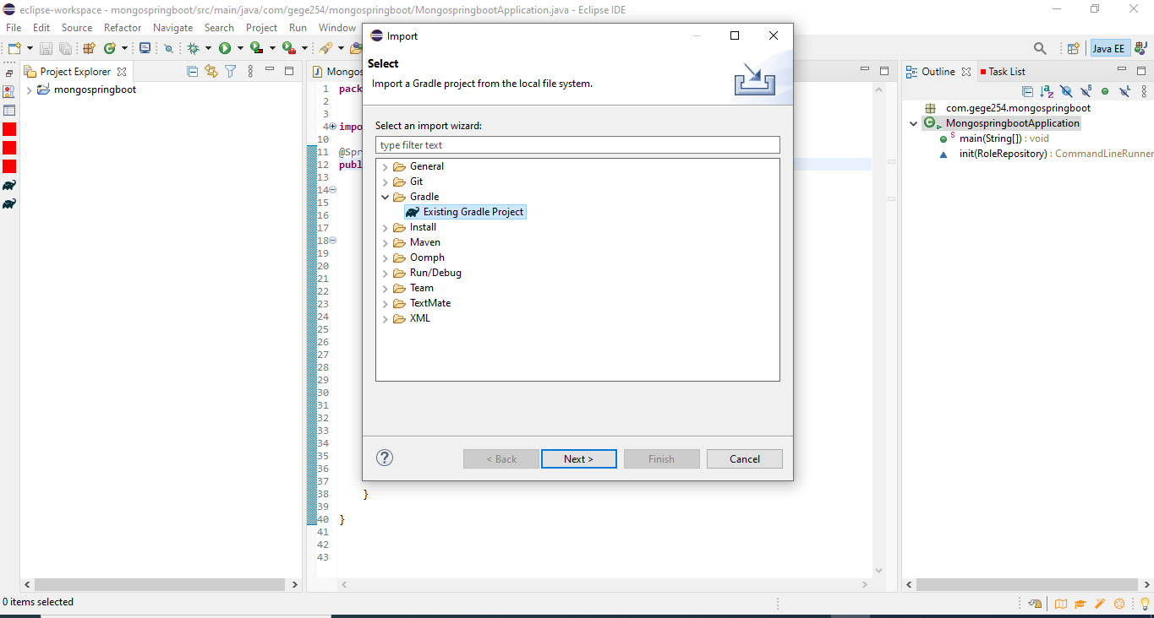

1. Click next until you find the window below to go browse the area where your spring boot folder is stored. After that click finish to open the project on your Eclipse IDE.



1. Make sure you have internet connection since the application will download the dependencies from the built gradle thus it time until all the gradle has built all the dependencies until you do not see any errors on your project as seen below. Now you are ready to run the application

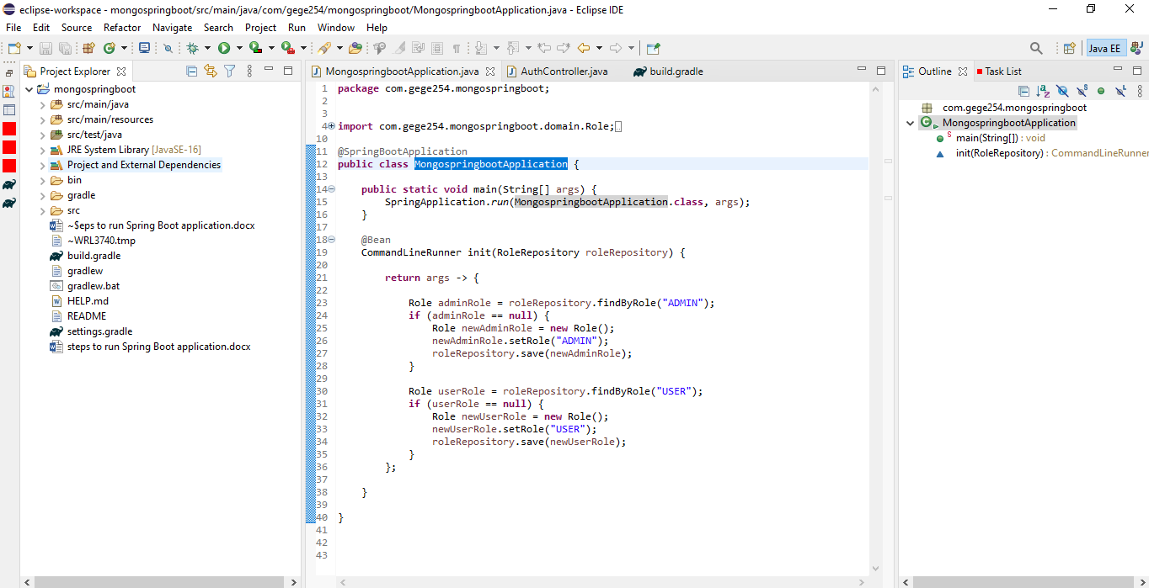

1. Now click on the green arrow named run to run the application and the terminal console should bring something like the image below to show that the application started successfully. Kindly note the console may be below the IDE not necessary should be where mine is located.

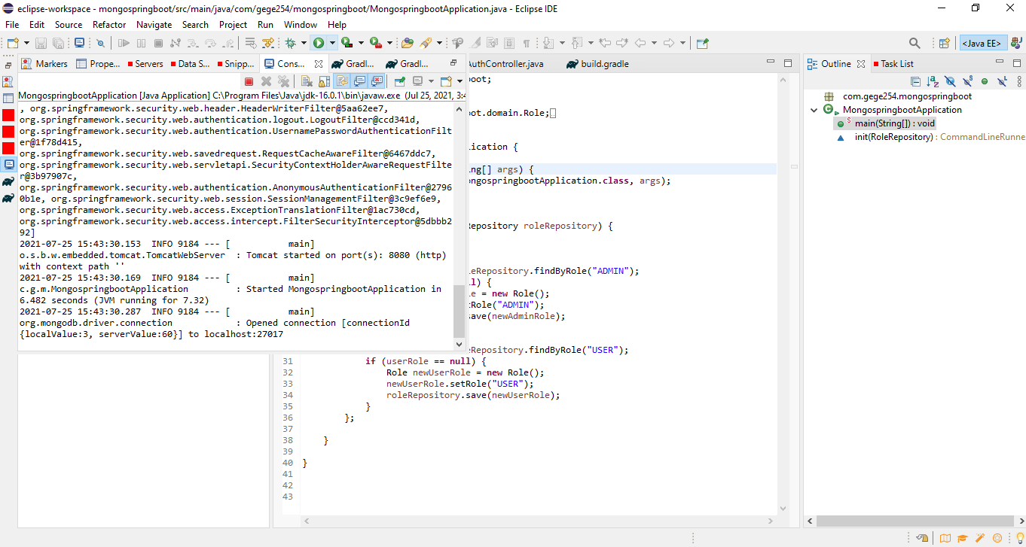

1. Now launch any of your browser and type localhost:8080 as shown below to start the application on a browser as shown below. If your browser windows show you the interface below you are ready to use the application. Click the blue button with label here to either log in or sign into the application.

